UNIVERSITY STUDENT CATEGORY
REGISTRATION FORM ROUND 2
BACH KHOA INNOVATION 2025
- TEAM’S NAME:
AITEK
- TEAM LEADER
Full name: TIEU CHI
ID Number (if any): 2310354
Email (HCMUT/ personal email): chi.tieuchi@hcmut.edu.vn
Phone number: 0703536941
- MENTOR (IF ANY)
Full name: PHAM TRAN DANG QUANG
Title: Lecturer
Working unit: Faculty of Transportation Engineering
Email: quangtdpham@hcmut.edu.vn
Phone number: 0777733392

PROJECT’S INFORMATION
- PROJECT’S NAME: AutoMate
Research field (Maximum 3 options):
- Electricity and Electronics;
AutoMate utilizes embedded systems such as STM32 microcontroller, along with components like microphones, and LED modules - requiring deep knowledge in electronic circuit design, power management, and real-time signal processing.
- Transport Engineering;
AutoMate is designed to interface directly with various vehicle systems via UART/I2C/CAN protocols, making it a practical application of transport system integration and in-vehicle network communication.
- SUMMARIZING YOUR IDEA/PROJECT (Maximum of 500 words)
Interacting with vehicle functionalities while driving often necessitates attentional shifts away from the primary task of driving, presenting potential safety hazards. Furthermore, prevailing voice assistant solutions frequently rely on consistent internet connectivity, which can limit their performance and reliability, particularly in areas with poor network coverage. Therefore, we develop AutoMate, a voice-controlled virtual assistant system designed for in-car integration, to directly address these challenges. It aims to enhance the user experience and improve driving safety by providing an intuitive and dependable method for hands-free vehicle interaction.
Functioning as an intelligent chatbot, AutoMate is capable of understanding and executing a range of simple driver commands. These include controlling vehicle lights, adjusting air conditioning settings, providing warnings for low fuel levels, monitoring tire pressure, and issuing reminders for routine maintenance tasks such as oil changes or scheduled vehicle inspections.
A core advantage of the AutoMate system is its operation via offline speech recognition technology. This ensures consistent and reliable performance without dependence on internet connection, a critical feature for operation in remote locations or during network outages. The chatbot interfaces directly with embedded microcontrollers (Raspberry Pi, STM32,…) utilizing standard communication protocols such as UART, I2C, or CAN, thereby enabling real-time control over the vehicle's hardware components.
Beyond its technical capabilities, AutoMate is also conceived as a visually appealing miniature robot model situated on the vehicle's dashboard, dually serving as a distinctive decorative element. Its modern and friendly design introduces a degree of personalization and a futuristic aesthetic to the vehicle's interior.
By combining advanced functionality with considered aesthetics and practical utility, AutoMate presents itself as an intelligent and stylish solution poised for the next generation of automotive experiences. Its scalable architecture ensures readiness for future enhancements, including navigation assistance, deeper smartphone integration, and the incorporation of AI-powered behavioral learning algorithms.
- DETAILS OF YOUR IDEA/PROJECT (Minimum of 300 words)
Describe in detail your idea/project.
The solution/idea (product/service) is clear and appropriate to the problem.
The idea (product/service) is innovative and unique, addressing problems and challenges with creative solutions.
It demonstrates clear improvements in business processes by introducing new techniques or methods to enhance efficiency or quality.

a. Introduction and Problem Statement
The rapid evolution of automotive technology has introduced increasingly complex human-vehicle interactions, often becoming a significant contributor to driver distraction and traffic safety risks. Infotainment systems, for example, are a leading source of user complaints, with J.D. Power reports indicating that 90% of these issues stem from non-intuitive design. This complexity necessitates manual interactions, such as using touchscreens, which scientific studies have shown can induce higher cognitive load and distraction than physical buttons.
Critically, driver distraction has severe consequences. Research from the AAA Foundation for Traffic Safety highlights that drivers can be distracted for over 40 seconds by in-car tasks, while just 2 seconds of eyes off the road doubles crash risk. This contributes to the alarming accident rates in Vietnam, where nearly 10,000 fatalities were recorded in 2024 (according to Vietnamnet). Recognizing this danger, Vietnamese law, specifically Decree No. 168/2024/ND-CP (Article 6, Clause 5, Point h), now stipulates significant penalties. For instance, car drivers using a mobile phone handset or other electronic devices while the vehicle is in motion face substantial fines ranging from VND 4,000,000 to VND 6,000,000, in addition to potential demerit points on their driving license.
Furthermore, many existing virtual assistant systems rely on continuous internet connectivity, limiting their reliability in areas with poor network coverage - a known issue in various regions of Vietnam. This can force drivers back to manual, distracting interactions.
AutoMate directly addresses these critical challenges by offering an intelligent, reliable, and inherently safer virtual assistant solution, designed for consistent offline operation and intuitive control.

b. The AutoMate Solution:
AutoMate is a voice-controlled virtual assistant system, specifically engineered for automotive integration, with two primary objectives: Enhancing user comfort and convenience and Maximizing driver safety. The core principle of the AutoMate solution lies in its full offline operational capability. This ensures the system is always ready to respond to user commands promptly and accurately, irrespective of internet connectivity status.
The system is developed through a flexible, three-phased approach. Phase 1 focuses on controlling basic, non-CAN bus integrated devices, thereby proving the core concept's feasibility and effectiveness.

c. Detailed Technical Architecture (Phase 1)

In the initial phase (Round 1), the system architecture used Raspberry Pi 5 as the voice recognition core, which communicated with STM32_1 via I2C. STM32_1 then relayed commands to STM32_2, also over I2C. Both STM32 microcontrollers managed direct hardware control for basic, non-CAN automotive functions (e.g., lighting, air conditioning), without involvement of the vehicle’s CAN network.
Current Phase Architecture (Round 2):
In the updated architecture, after offline voice recognition is processed by the Raspberry Pi 5, command data is transmitted to STM32_1 using the I2C protocol. The major improvement is that STM32_1 and STM32_2 now communicate with each other over the CAN protocol, utilizing dedicated CAN transceiver modules.
Although the system is not yet connected to the vehicle's CAN High/Low network, the team has successfully implemented CAN-based communication between STM32_1 and STM32_2. This demonstrates the feasibility of a scalable, multi-controller CAN bus network, which is essential for Phase 2.
Technical Highlights:
- Raspberry Pi 5: Powers offline speech recognition (Vosk), sends recognized command via I2C to STM32_1.
- STM32_1 (Main Controller): Receives commands from Raspberry Pi 5 (I2C), transmits them to STM32_2 via CAN bus (using CAN transceiver modules).
- STM32_2 (Execution Controller): Receives commands from STM32_1 over CAN, actuates relays or power drivers to control target automotive devices (e.g., interior lighting, AC).
- Proof of Concept: This CAN-based inter-microcontroller communication serves as a critical technical milestone, paving the way for future integration with the actual vehicle CAN bus.

d. Physical Design: Innovation and Uniqueness
One of AutoMate's most innovative aspects is its physical design, transforming it from a mere software system into a tangible in-car presence:
- Structure: AutoMate has a special look. It features a custom-designed base unit that sits on your car's dashboard. This themed base neatly holds all the main electronics (like the Raspberry Pi and STM32 circuits. A cube-shaped Robot Figure (4-5cm), with a display face) is placed on this roadway, acting as the tangible interactive key.
- Activation Mechanism: The robot figure serves as a physical key. The entire system activates only when the figure is placed onto the base unit. This connection is secured by magnets, which can also cleverly integrate with a magnetic switch (like a reed switch or Hall sensor) to complete the power circuit.
- Significance: This design offers more than just aesthetics; it provides a unique interaction, a form of security/control, and enhances vehicle personalization.

e. Improvements and Efficiency
AutoMate introduces clear improvements to the driving process:
- Enhanced Safety: Significantly reduces the need for drivers to look away or take their hands off the wheel.
- Increased Efficiency & Convenience: Allows for quick, intuitive control of vehicle functions using only voice commands.
- Innovation & Uniqueness: The blend of offline voice recognition, the physical key concept, and direct hardware control creates a distinct and compelling solution.

f. Development Roadmap
Phase 1 (Current): Proof-of-Concept with Internal CAN Bus
- Achieve robust CAN communication between STM32 controllers.
- Complete offline voice command flow: Voice input → I2C (RPi5 to STM32_1) → CAN (STM32_1 to STM32_2) → Hardware control.
- Validate the system architecture and readiness for CAN expansion.
Phase 2: Full Integration with Vehicle CAN Bus
- Connect STM32 modules to the vehicle’s CAN network.
- Enable advanced features: Read real-time vehicle data, diagnostics, and deeper control.
- Enhance system compatibility with more car models.
Phase 3: User Experience & Commercialization
- Enable voice feedback/response for natural human-machine interaction.
- Offer premium/custom voice packs for user personalization.
- Add selfie/photo capture and other experiential features.
- Scale up commercialization: production, distribution, support.
- Continuously refine based on broad user feedback.
This step-by-step roadmap allows AutoMate to move from core technical validation, to real vehicle integration, and finally to a richer user experience. By combining CAN-based control, connection to real car systems, and features like voice feedback or selfie capture, AutoMate is ready to deliver both safe, intuitive car control and enjoyable, personalized journeys for drivers - making it practical for commercial launch.

Note: (*) Criteria are encouraged, but not mandatory.
- BUSINESS MODEL
The value proposition is presented and explained.
The revenue model is well-defined, highly potential, and testable.
The business model structure and key assumptions are clearly defined and feasible.
Determining LTV (Lifetime-value per Customer) and COCA (Cost- of Customer-Acquisition) shows a lot of potential. (*)
(The project can be presented using a table format based on the criteria of the Lean Canvas model.)
AutoMate introduces an innovative yet practical business model, focusing on bridging the technological gap for non-smart vehicles through a cost-effective, modular, and personalized dashboard assistant. The product does not simply provide functionality; it enhances driver safety, satisfaction, and style - particularly for users of older cars or budget vehicles.
- Value Proposition:
- Superior Safety: Minimize distractions, ensures hand-on-wheel, eyes-on-road operation.
- Offline Reliability: Offline voice assistant that works anywhere - no internet required. In short functions seamlessly without Internet anytine, anywhere.
- Personalization & Mordern Appeal: Customizable robot design (colors, voice, packs) that adds visual flair to the vehicle interior.
- Simple & Intuitive Interaction: Physical robot key offers a tabgible and engaging user interface.
- Affordable for Retrofit Market: Brings smart technology to older or standard vehicles at a reasonable price point, with a modular system that is easy to repair and upgrade.

Revenue Model and Pricing Structure
Our revenue model is based on a "Buy-Once, Use-Forever" principle for core functionalities, complemented by the sale of value-added products and services to maximize Lifetime Value (LTV). Our primary revenue streams include:
- Direct Product Sales: The core revenue is generated from the direct sale of the complete AutoMate kit at a suggested retail price (SRP) of VND 2,999,000 per unit.
- Premium Customization: We offer optional physical products and services, including:
  - Pre-designed Robot Key models (SRP: VND 249,000).
  - A bespoke design service for personalized Robot Keys (SRP: VND 799,000 - 999,000).
- Paid Software Upgrades: Major future feature releases will be offered as one-time purchase upgrades, such as new voice packs or advanced command sets (SRP: VND 349,000).
- Service Bundles: We will partner with garages and service centers to offer installation packages.

Financial Viability & Sustainability Analysis
To prove the model's sustainability, we conducted an analysis of Customer Acquisition Cost (COCA) and Lifetime Value (LTV).
Key Assumptions
- Market Need Assumption: We assume there is a significant, addressable market of standard/older vehicle owners who have a genuine need for smart, affordable retrofit solutions. This assumption is validated by market data on traffic safety risks and infotainment system complexity, as detailed in the Market Feasibility section.
- Core Value Assumption: We assume the 100% offline capability is a critical competitive advantage that customers will value over internet-dependent alternatives. This belief is rooted in the known unreliability of network coverage in certain regions, positioning AutoMate as a more dependable solution.
- Revenue Model Assumption: We assume the "Buy-Once, Pay-for-Major-Upgrades" model aligns with customer psychology for hardware products. Its viability is supported by a positive LTV/COCA ratio (>3), which indicates strong profitability even with conservative add-on purchase rates.b. Customer of Acquisition Cost (COCA) Analysis.
COCA is estimated based on the projected marketing and sales budget for the first year, divided by the target number of new customers.
- COCA ≈ VND 400,000 per customer.
Important Note: This COCA is aligned with acquisition costs reported for smart automotive accessories and consumer IoT products in Vietnam, typically ranging from 300,000–700,000 VND/customer (Source: Do Ventures 2022, Statista IoT Market Data). This figure of VND 400,000 reflects the high initial costs associated with the market entry phase, where significant investment is required for brand building and initial customer acquisition. It is, therefore, considered a conservative estimate. We expect COCA to trend downwards in subsequent years, driven by word-of-mouth marketing, increased brand recognition, and the optimization of advertising channels. Using this higher, first-year COCA for our analysis provides the most prudent and robust assessment of the project's financial viability.
Lifetime Value (LTV) Analysis
LTV is the total gross profit an average customer is expected to generate over their entire lifespan (assumed to be 3 years). To provide a comprehensive view, we have modeled three scenarios: Pessimistic, Base-Case, and Optimistic.
LTV Calculation Table:
Profit Contribution | Pessimistic Scenario | Base-Case Scenario | Optimistic Scenario
Profit from Main Product  (Price VND 2,999,000, 40% Gross Margin) | 1,199,600 | 1,199,600 | 1,199,600
Expected Profit from Robot Key  (70% GM, Purchase Rate: 20%/40%/55%) | 34,860 | 69,720 | 95,865
Expected Profit from Design Service (70% GM, Purchase Rate: 2%/5%/8%) | 11,186 | 27,965 | 44,744
Expected Profit from Software  (95% GM, Purchase Rate: 10%/20%/30%) | 33,155 | 66,310 | 99,465
TOTAL LTV (Gross Profit) | VND 1,278,801 | VND 1,363,595 | VND 1,439,674
Conclusion: LTV/COCA Ratio and Growth Potential
- LTV Range: Estimated to be between ~VND 1.28 million and ~VND 1.44 million.
- LTV/COCA Ratio: Ranges from 3.2 to 3.6.
An LTV/COCA ratio greater than 3 is a benchmark indicator of a healthy, scalable, and profitable business model. This demonstrates that AutoMate is not only a viable project but also possesses strong resilience against market fluctuations.
Pilot Market Validation
As part of our Product Testing and User Feedback, we will conduct a pilot deployment to validate both our technical architecture and business assumptions. 15–20 users from our target segments will test AutoMate over a month-long period. Data collected from usage logs and direct feedback will provide insights into user preferences, command effectiveness, and purchasing behavior. These findings will help refine our pricing tiers, upsell strategies, and installation service offers.

Go-to-Market & Operations
Distribution Channels
- E-commerce platforms (Shopee, Tiki, Lazada, Amazon).
- Automotive accessory shops and car maintenance service centers.
- Pop-up booths at motor shows and university tech events.
- Social media marketing targeting tech-savvy youth and ride-hailing communities.
Key Cost Structure
- Hardware: Costs for PCBs, sensors, microcontrollers, and casings.
- R&D: Expenses for software development and voice dataset training.
- Manufacturing & Packaging: Costs for assembly, labor, and packaging.
- Marketing & Sales: Advertising budget, partnership development, and customer service costs.
Competitive Advantage
- Unique Product Offering: No other mass-market assistant combines offline vehicle control with a distinct physical personality.
- Underserved Market Focus: Targets the low- to mid-range vehicle segment, a large and often overlooked market.
- Emotional Connection: The "robot companion" design has strong potential to build brand affinity and customer loyalty.
- Deep Hardware Integration: Superior to solutions that rely solely on Bluetooth or mobile apps.
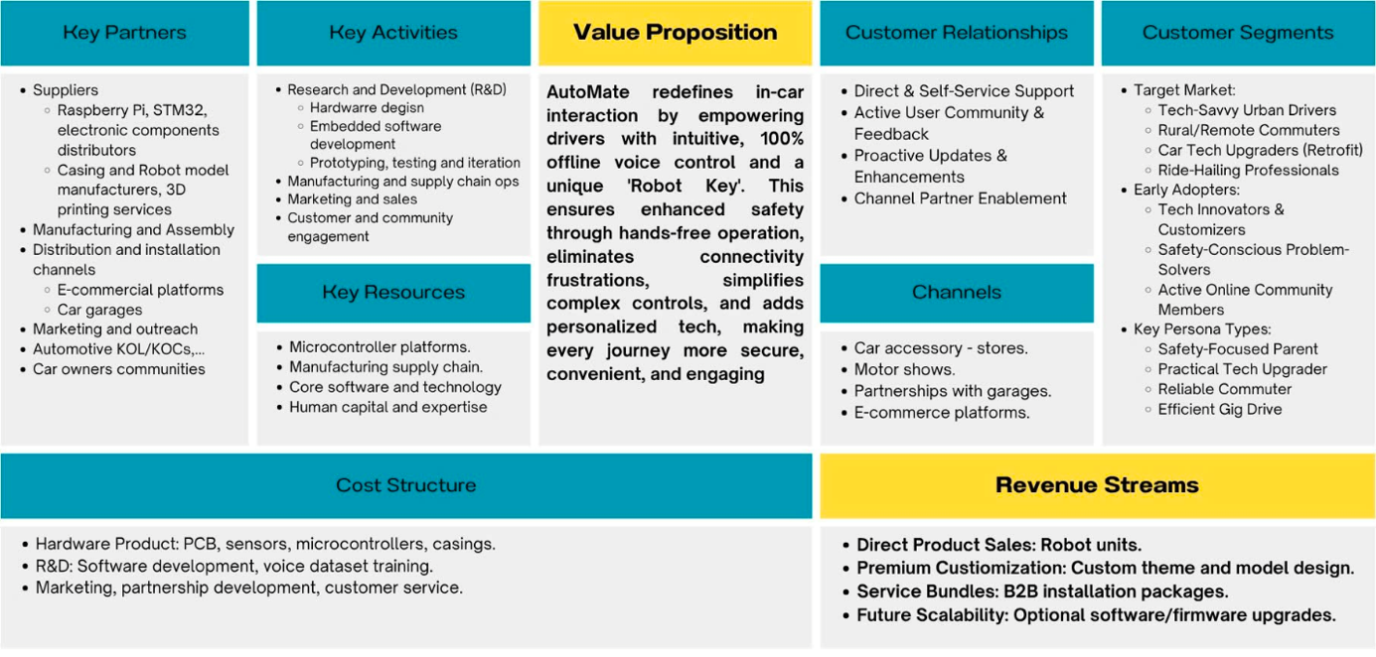
Business Model Canvas (BMC):
- MARKET FEASIBILITY
Defining the target market for the product/service using relevant data and research
Analyzing competition and defining clearly competitive advantages using a competitive matrix

a. Clear Market Needs
AutoMate directly addresses three urgent and interrelated needs of modern drivers:
- Maximum driving safety: Hands-free interaction reduces distractions and ensures full focus. This need is critical, as studies from the AAA Foundation for Traffic Safety indicate that looking away from the road for just 2 seconds doubles crash risk, and interactions with complex systems can divert attention for over 40 seconds. Furthermore, Vietnam recorded nearly 10,000 traffic fatalities in 2024 (according to Vietnamnet).
- Reliable functionality in all environments: The solution must operate completely offline. This is not only ideal for areas with inherently weak or no mobile coverage but also addresses the broader vulnerability of internet-dependent systems. For instance, significant disruptions to Vietnam's undersea internet cables, such as the incident in mid-2024 where three out of five lines were down, severely impacted nationwide connectivity and highlighted the risks of relying on online services for critical in-vehicle functions.
- Simple and stress-free interaction: Avoids the complexity of infotainment systems with intuitive voice commands and a tangible robot interface. This addresses a major user pain point, as J.D. Power reports highlight infotainment complexity as a top complaint, with 90% of issues stemming from non-intuitive design.

b. Market Size Estimation
Concept | Estimate | Explanation
TAM - Total Addressable Market | ~5 million cars | Cars under 9 seats circulating (~3.45 million) and expected to be sold in Vietnam (~500.000-600.000/year) within 3-5 years.
SAM - Serviceable Addressable Market | ~2 million cars | Vehicles without built-in virtual assistants or owners seeking upgrades
SOM - Serviceable Obtainable Market | 12,000 units | 2% of SAM as a realistic entry goal for the first 3 years

c. Target Customers
User Behavior Insights
Based on preliminary user interviews and secondary data, we identified key behavioral trends:
- Many drivers frequently multitask while driving due to the lack of voice-based alternatives.
- Offline reliability is viewed as a must-have, not a nice-to-have, especially for intercity drivers and rural users.
- Users expressed a preference for customizable and “human-like” robot interfaces over impersonal app-based assistants, especially in solo driving scenarios.
These insights support our design focus on hands-free operation, offline reliability, and emotional engagement via the physical robot form.
Therefore, AutoMate targets the following key customer segments:
- Young to middle-aged tech-savvy individuals in urban and suburban areas.
- Ride-hailing or service vehicle drivers needing safe, hands-free operations.
- Intercity travelers seeking reliable offline functions.
- Owners of standard or older vehicles looking to modernize affordably.
d. Competition & Unique Advantages
Current Competitors | Description | Main weekness
Integrated assistants  (CarPlay, Android Auto) | Smartphone-based integrated voice assistants | Completely dependent on Internet connectivity
Premium OEM solutions (Cerence, Sensory) | Deeply integrated solutions from vehicle manufacturers | High cost, inaccessible to most average users
In-car robots  (e.g., Nomi/Nio) | Emotion-focused robot assistant, limited to certain high-end EVs | Not deeply integrated with vehicle hardware or control systems
AutoMate’s Unique Advantages:
- 100% offline operation for core car control.
- Physical “robot key” interface - unique brand identity.
- Focus on real safety and usability, not flashy features.
- Deep hardware integration (STM32) - surpasses Bluetooth or app-only methods.
- Affordable (~3M VND) - accessible for the retrofit market.

e. Supportive Trends
- Rising awareness of traffic safety and intelligent driving aids.
- Growing trend of in-car personalization among younger drivers.
- Expansion of Edge AI and DIY tech communities backing offline innovation.
- Strong retrofit demand: upgrading older cars with affordable smart tech.

f. Competitive Matrix
Product | CarPlay / Android Auto | Cerence / Sensory | In-car robots | AutoMate
Offline Functionality | ✗ | ✗ | ✗ | ✓
Hardware Control (e.g., lights, AC) | ✗ | ✓ | ✓ | ✓
Smartphone Ecosystem | ✓ | ✓ | ✗ | ✗
Emotional  Decorative | ✗ | ✗ | ✓ | ✓
Affordability  (≤ 3M VND) | ✓ | ✗ | ✗ | ✓
Navigation ability | ✓ | ✓ | ✓ | ✗
Customization / DIY Support | ✗ | ✗ | ✓ | ✓
Target Market | Smartphone users | Premium vehicle manufacturers | High-end electric vehicle users | Mass-market drivers, youth, service drivers

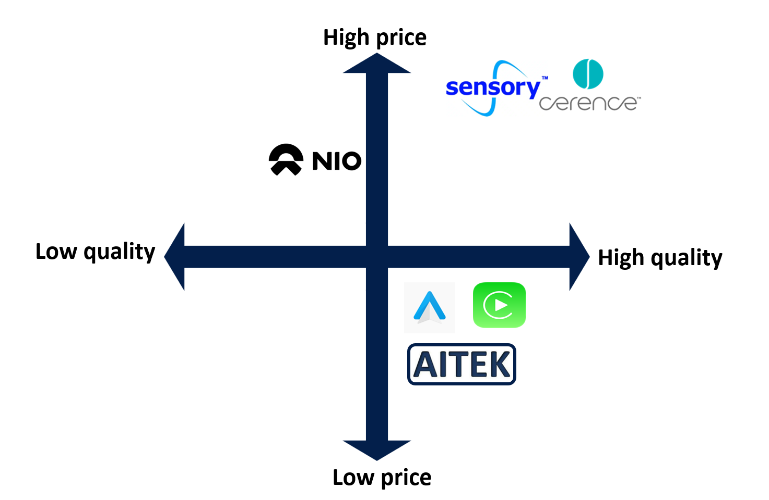
- INTERNAL ANALYSIS OF THE PROJECT
The project can be presented using the SWOT model
STRENGTHS:
- Offline voice recognition: stable even in poor network zones.
- Friendly, customizable physical form (robot look) with emotional appeal.
- CAN/I2C/UART-based: compatible with both new and old vehicles.
- Modular hardware for easy repair and part replacement.
- Compact and aesthetic design improves interior experience.
WEAKNESSES:
- Production cost per unit remains relatively high for small batches.
- Limited vocabulary set in early-stage voice command system.
- Dependency on CAN protocols may require wiring expertise during installation.
- Requires continuous UX refinement to avoid user fatigue.
OPPORTUNITIES:
- Ride-hailing and car rental sectors rapidly growing.
- Policies supporting startup innovation and local tech manufacturing.
- Emerging awareness about traffic safety and smart mobility.
- Partnerships with universities, vocational schools for training tools.
THREATS:
- Market preference for smartphone-based assistants (Google, Siri).
- Supply chain issues for chips and microcontrollers.
- User skepticism toward aftermarket electronics due to fear of damaging vehicles.
- Copycat products entering the market post-prototype success.
- DEVELOPMENT STRATEGY (*)
Short Term (1-3 months): Building a fully functional prototype
- Finalize the prototype with full integration of offline voice control to perform key operations on a test vehicle (Mitsubishi), including:
  - Turning on/off interior lights, air conditioner.
  - Reading and reacting to signals on CANH and CANL vehicle lines.
  - Alerting empty fuel and reminding for routine maintenance tasks such as oil changes.
- Ensure synchronization between microcontrollers (STM32) and CAN bus signals of the vehicle.
- Run intensive lab tests to validate offline voice commands, electrical stability, and safety compliance.
Mid Term (3-6 months): Pilot Testing and Compatibility Expansion
- Conduct compatibility testing on various car models from different brands and years of production.
- Deploy early-stage pilots with selected users (e.g., ride-hailing drivers, car service providers).
- Collect feedback on usability, design, and effectiveness; refine voice command database and improve firmware responsiveness.
- Begin outreach to automotive accessory retailers for future distribution opportunities.
Long Term (6-12+ months): Feature Expansion and Market Readiness
- Introduce optional advanced features such as:
  - AI-based behavior learning (adapting to user habits).
  - Basic Bluetooth smartphone pairing.
  - Mutiple designs for many concepts.
- Prepare for limited-scale production with optimized manufacturing cost.
- Develop brand identity and explore crowdfunding, partnership, or incubation opportunities if feasible.
- HUMAN RESOURCES
Who is involved in the project, and what are the roles and responsibilities of each team member?
The AutoMate project is the result of a dedicated five-member team, each specializing in a key technical or strategic aspect of development:
- One member is in charge of embedded programming, handling the integration between the microcontroller (STM32) and vehicle signals via CAN, UART, and I2C protocols.
- The second team member takes the lead on product prototyping and industrial design, specifically the external design of the AutoMate robot (shape, size, materials, and visual personality). This member also handles core electronic circuit design, power management, and electrical safety features.
- A third member takes the lead on voice control logic, modifying offline voice datasets and configuring the recognition structure to match Vietnamese commands.
- The fourth member supports the prototyping process and the refinement of the robot's external design. This member's primary role is expanded to focus on conducting initial market research, product-focused competitive analysis, and assisting with the commercialization aspects of the AutoMate project.
- Finally, one member (team spokesperson) takes on the support role of product introduction and communication. This includes observing the entire project workflow, writing the product report, preparing presentation materials, and representing the team during pitches and competitions.
We are especially grateful to our mentor, Mr. Pham Tran Dang Quang, Lecturer at the Faculty of Transportation Engineering, for his invaluable guidance. His industry insights and critical feedback helped us refine both our system architecture and user-centric design thinking.
HIGH POTENTIAL TO CONTRIBUTE TO SOCIETY/COMMUNITY?
AutoMate contributes to road safety by reducing driver distraction through hands-free operation. For older or rural users without access to smart features, AutoMate provides an accessible, low-cost way to improve control and vehicle awareness.
It also helps promote digital equity by ensuring that technological enhancements are not exclusive to high-end vehicles. For communities with poor internet access, this offline solution empowers more inclusive use of technology.
In the educational space, AutoMate can be adapted as a teaching aid for embedded systems, voice control programming, or vehicle diagnostics, supporting STEM learning at universities and vocational schools.
Furthermore, the robot’s friendly form encourages driver mental well-being by introducing a humanized companion on the road - a small but meaningful contribution in a stressful driving culture.
THE TEAM'S ASPIRATIONS AND OBJECTIVES IN SUBMITTING THE PROJECT TO THE COMPETITION
AutoMate is more than a technical project - it reflects our team’s vision of accessible, inclusive, and humanized vehicle technology. By participating in Bach Khoa Innovation 2025, we seek not only recognition but also mentorship, collaboration, and real-world validation.
We hope to turn AutoMate into a tangible solution used on Vietnamese roads, especially in everyday cars that are often overlooked by the tech industry. The competition gives us a platform to connect with investors, mentors, and fellow innovators.
Long-term, we aspire to build a Vietnamese product line that proves local creativity can solve local challenges - and we hope AutoMate will be one of the first steps in that journey.

J.D. Power. (2023). 2023 U.S. Multimedia Quality and Satisfaction Study. Retrieved May 28, 2025, from https://www.jdpower.com/business/press-releases/2023-us-multimedia-quality-and-satisfaction-study
OKW News. (April 13, 2024). AAA Urges Drivers To Tune Into Driving, Tune Out Distractions. Retrieved May 28, 2025, from https://okwnews.com/news/lifestyle/april-is-distracted-driving-awareness-month/
Vietnamnet. (December 31, 2024), 360 traffic accidents, 423 casualties due to drivers running red lights. Retrieved May 28, 2025, from https://vietnamnet.vn/360-vu-tai-nan-giao-thong-423-nguoi-thuong-vong-do-tai-xe-co-vuot-den-do-2358889.html
Government of Vietnam. (2024, December 26). Decree No. 168/2024/ND-CP on Sanctioning of Administrative Violations in Road Transport Order and Safety; Demerit Points and Restoration of Driving Licenses. Specific penalties for using a mobile phone while driving are detailed, for example, in Article 6, Clause 5, Point h. Retrieved June 1, 2025 from https://xaydungchinhsach.chinhphu.vn/muc-phat-hanh-vi-su-dung-dien-thoai-khi-dieu-khien-o-to-xe-may-xe-dap-tham-gia-giao-thong-119250102151707435.htm?gidzl=YcUaRsH0Un-8SA1WO5Po6ujng65vN7PBb72kDNjO8KsGSlfcA0eY6CSc-ZDu3obCadVwDJdS7kf8P4bs4G
Do Ventures. (2022). Vietnam Innovation and Tech Investment Report 2022. https://doventures.vc/en/insights/reports/vietnam-innovation-and-tech-investment-report-2022
Reuters. (2024, June 17). Three of Vietnam's five undersea internet cables are down. https://www.reuters.com/world/asia-pacific/three-vietnams-five-undersea-internet-cables-are-down-2024-06-17/
Xinhua. (2025, January 15). 9 pct of households in Vietnam own cars: Survey. https://english.news.cn/20250115/b505ffda95144d44a48b97b393f62b6b/c.html
Vietnam News Agency. (2025, January 25). Vietnam's automobile industry to face multiple challenges in 2025. VietnamPlus. https://en.vietnamplus.vn/vietnams-automobile-industry-to-face-multiple-challenges-in-2025-post308759.vnp

